Title | The CLARIN Ambassadors Programme | 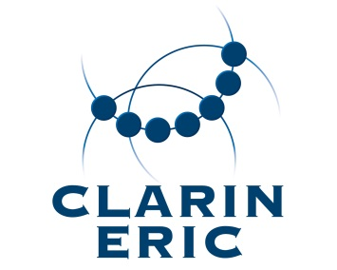
Version | 0.1
Author(s) | DF
Date | 21-12-2018
Status | draft - for information and discussion
Distribution | BoD, NCF, UI
ID | CE-2019-1372

The CLARIN Ambassadors Programme

General
- Background and motivation: The aim of the CLARIN Ambassadors programme is to raise awareness about and encourage participation in CLARIN ERIC in disciplines and communities who are not yet fully integrated in CLARIN.
- Proposed model: We nominate 3-5 ambassadors with a 2-year mandate who to actively promote CLARIN as described in Section 2.
- Total budget available: 10.000 EUR, to be used for small travel budget per ambassador.

Tasks
- Attend an internal introductory webinar and study the information package to learn about CLARIN's organization, strategy, technical infrastructure and activities.
- Proactively seek opportunities to promote CLARIN within relevant projects, scholarly networks, institutions, research infrastructures, etc.
- Select and attend 1-3 key events in their field per year to actively promote CLARIN (e.g. keynote talks, panel discussions, masterclasses).
- Agree to be featured in CLARIN's newsletter, website and printed promotional material (e.g. interview, blogpost, brochure).

Nomination
- National Coordinators and User Involvement Representatives nominate candidates and indicate their area of expertise, aiming for about 2 communities traditionally close to CLARIN (e.g. learner corpora researchers, translation studies) and about 2 communities less close to CLARIN (e.g. literary studies, parliamentary studies).

Timeline
- Proposals for candidates and selection: end of January 2019
- Webinar and information package for the ambassadors: end of February 2019
- Evaluation of the instrument: end of March 2020

